* For pushing the data from Visual Studio we need to installa Cosmos DB Package in Visual Studio. 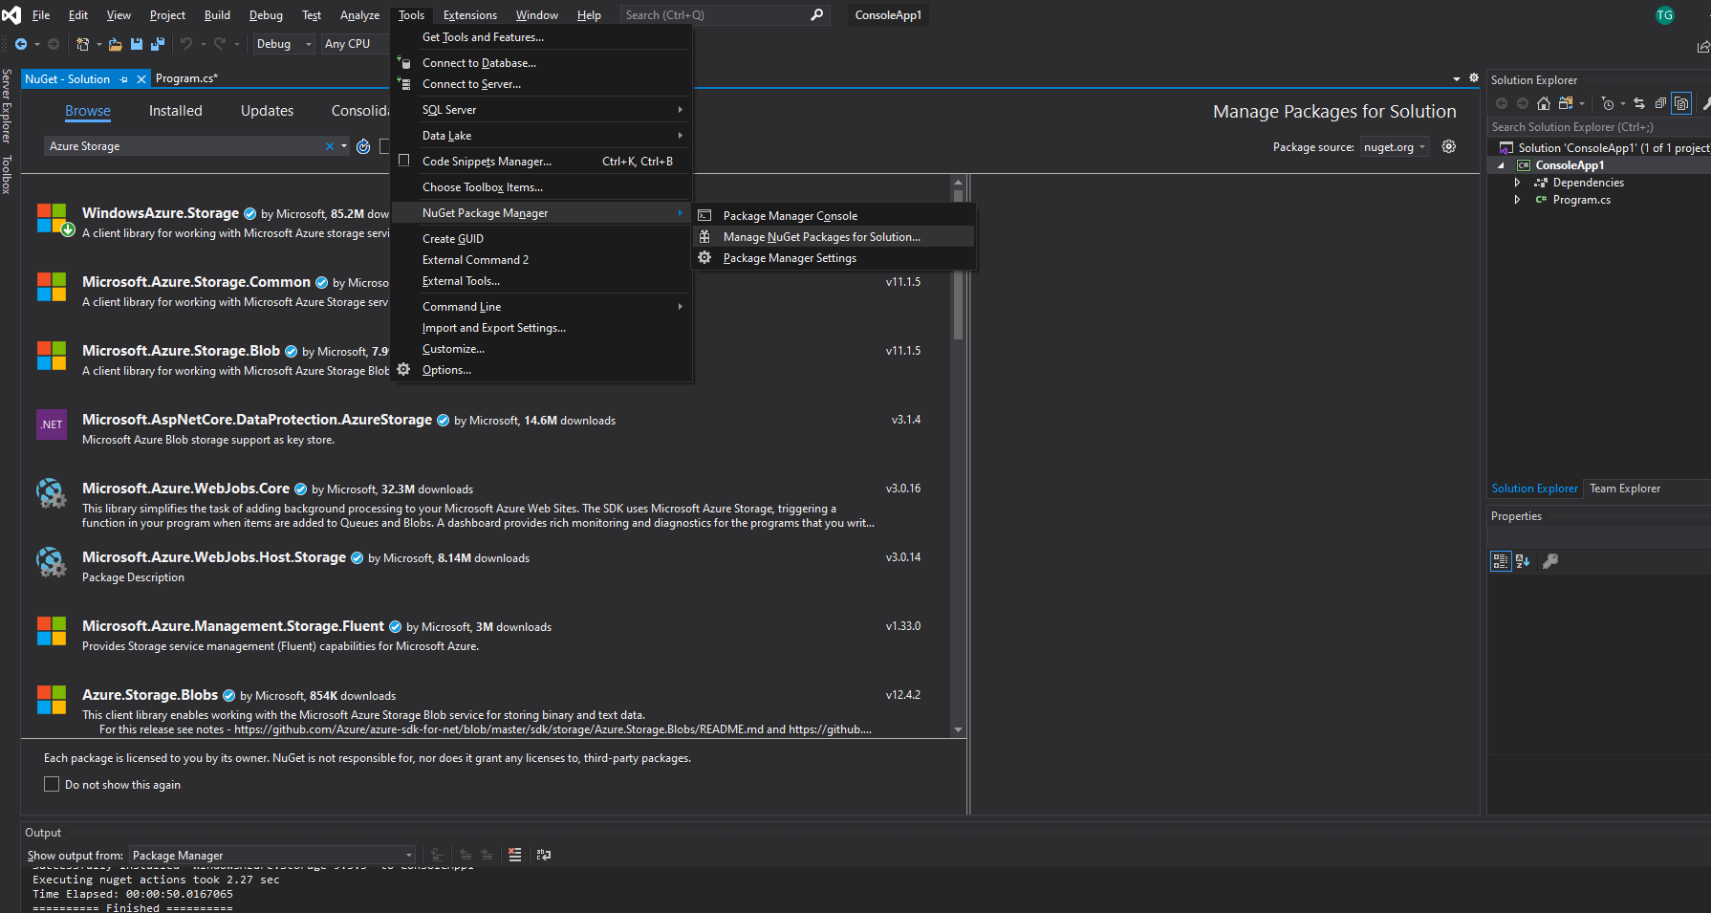
* For Cosmos Document DB is used, attach and install it to the pachake and you are good to go. 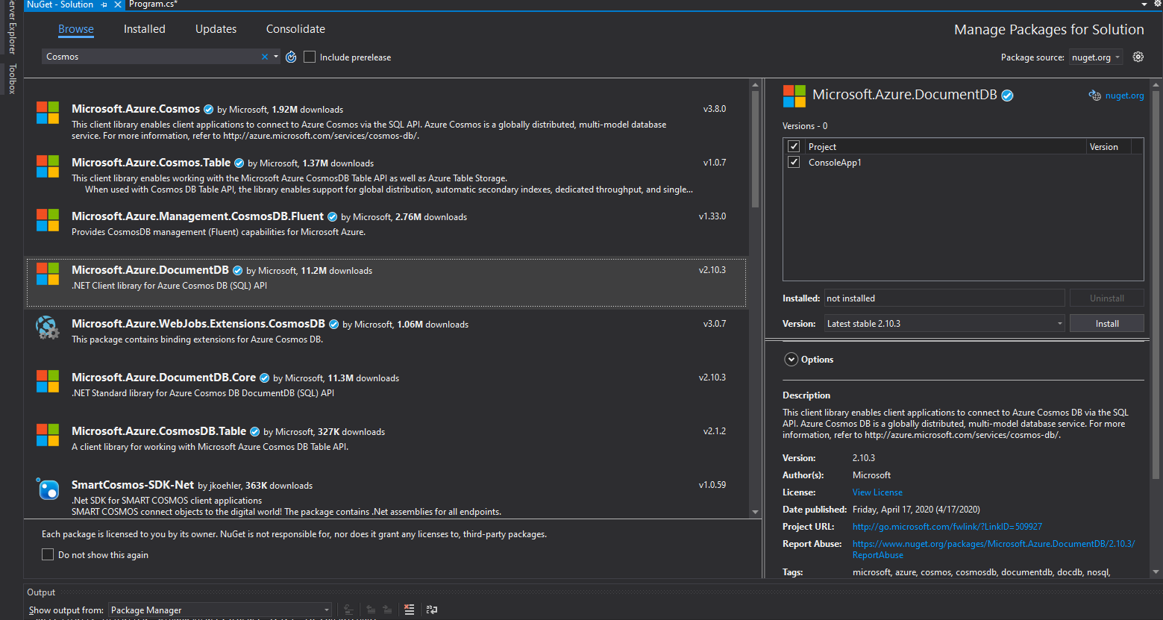
* Program for injection of data into Azure Comos DB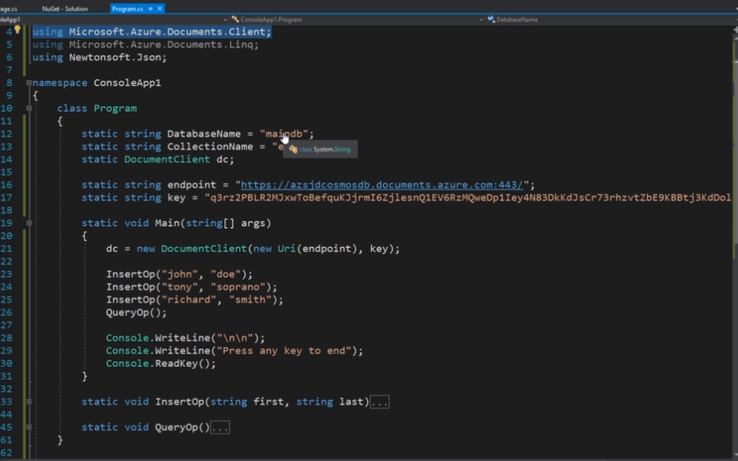
* We have to separate the endpoint and the key in the program.
* For Cosmos DB as it is a NOSQL we can take the string and convert it into Json for storing it. 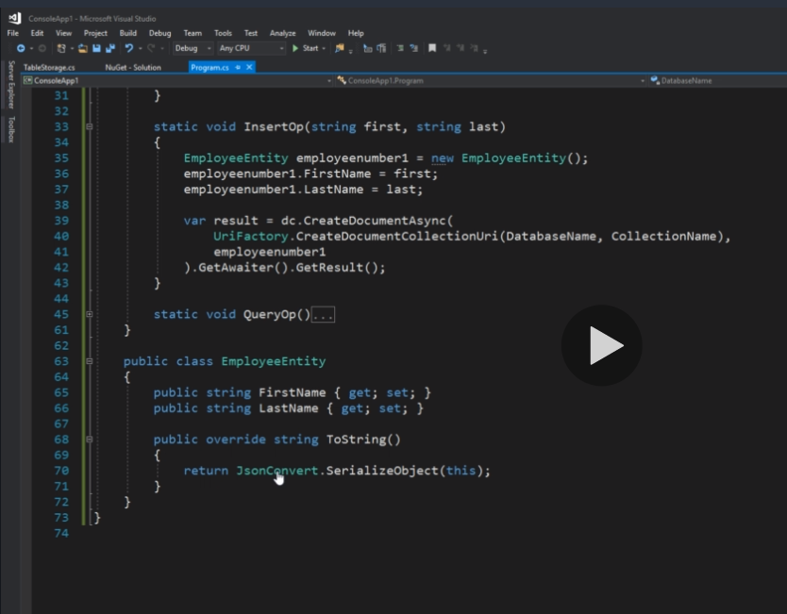
* In main db an unstructured data is stored as json data.
* This code is used to query the data out of CosmosDB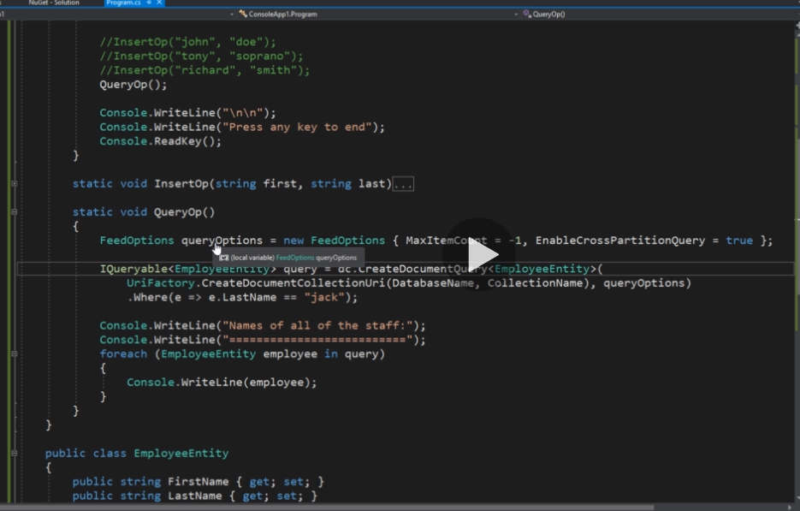
* Building queries CosmosDB is more or less similar to Storage Accounts its just that CosmosDB has that Enterprise grade data storage and replication with extra scalability and other imp features.